**Assignment #3: Essay writing**

**OVERVIEW:**

* Select a piece from the following options (transcripts are on my teacher page):

❑ TEDTalk (Christopher Bell and superheroes) ❑ Steph Curry speech on gender equality

❑ Emma Gonzalez gun reform speech ❑ Why I Kneel essay

❑ NRA piece after Sandy Hook shooting ❑ Why I Stand essay

❑ Kellie Marie Tran (*Star Wars*) piece on identity/pride ❑ Greta Thunberg speech to Congress (climate)

**TASKS:**

1. Close-read your piece and annotate (in pen or digitally). Be sure to label your annotations. Read for:

* Claim(s)
* Supporting evidence/details (at least 3)
* Address of opposition and refutation (if applicable—your piece might not do that)
* Appeal to emotion (at least 2) What emotion? Why?
* Appeals/stylistic techniques/rhetorical devices (at least 4)

**\*Note**: it is not enough just to label the claim, evidence, device; paraphrase claims/evidence in your

own words. For stylistic/rhetorical devices, make a *brief* note about its function/purpose.

2. Complete the graphic organizer—work must be typed. (see teacher page for the document)

**RUBRIC:**

**Article annotations-**claims/supporting evidence/opposition/ **✓+ ✓ ✓-**

refutation/stylistic elements/rhetorical devices

* Thorough
* Accurate
* Clear, original paraphrases
* Clear, insightful notes on device function/significance

**Graphic Organizer (typed) ✓+ ✓ ✓-**

* Accurate device/textual evidence of it
* Clear and accurate explanation of claim evidence/refutation/device
* Insightful and developed analysis with links back to the claim/purpose

/25

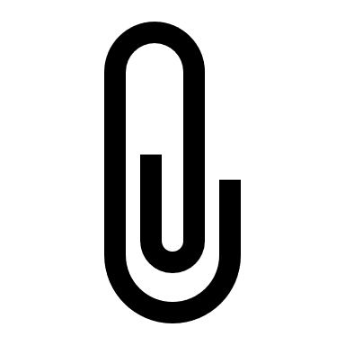

When you submit, you must staple materials in this order: Annotated transcript, graphic organizer, this rubric. If you are absent the day the work is due, you must email pics of your annotated transcript along with the attached word document of the graphic organizer by the start of class. Then, bring a printed copy of everything upon your return, please.